

Best Practices

Concierge Assistant

5 Things You May Not Know

1- When searching by last name The Concierge Assistant allows you to narrow your search by keying in a full or partial Last Name, followed by a comma and a full or partial First Name.

The example below would return entries for: It would not return entries for:

Barry, James Barry, John
Barrister, Jason Barrister, Jerry
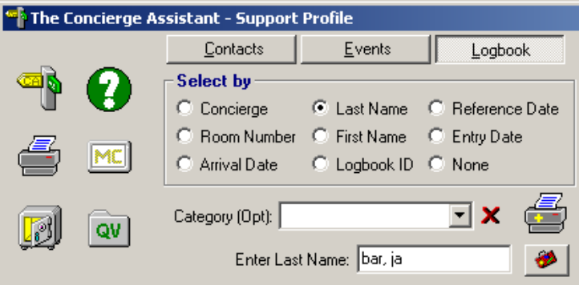

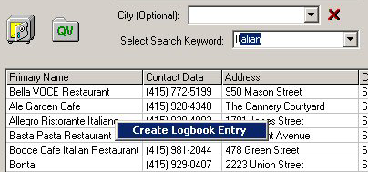
2- When using the Contact Search, you may right-click on a Contact to create a Logbook Entry. The Drag and Drop Contact Panel will automatically appear

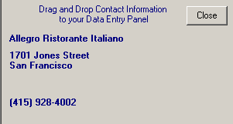

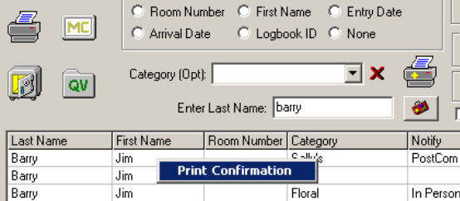
3- When using the Logbook Search, you may right-click on a Logbook Entry to Print a Guest Confirmation directly to your default printer.


4- ANYWHERE you may be in The Concierge Assistant you have three function keys available:

F2 – will launch the Calculator
F3 – will launch the Three Month Calendar
F4 – will print the Display Panel you are viewing.

5- In Events – when you select the Limited Dates Report . . .
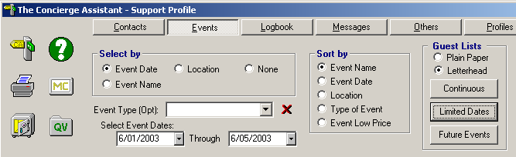

AND you have selected a range of Event Dates - the Report will print only those events occurring during that date range. This is Great for personalizing the report for your Guest’s stay.
